# **General Web Policy of CCSU**

### 

### General Web Design Policy

The Office of Marketing and Communications is responsible for the overall design of the CCSU website. As such, we reserve the right to modify any information, layout, navigation, etc. on the CCSU web server that does not conform to the CCSU official website design standards as outlined in the CCSU Website Style Guide.

Individual CCSU departments/centers/organizations are responsible for the **content** on their respective websites. The Office of Marketing and Communications will work with a representative from each department to help identify the objectives and needs for the website and will construct a design based on the content provided.

The Office of Marketing & Communication is responsible for the **presentation** of the web. Representatives for each website are encouraged to work with them to create a design that best meets their needs. Marketing & Communications will ensure that all the pages on the CCSU web server meet web standards and match the Central Style Guide. The office reserves the right to modify or remove **any** information, layout, navigation, etc. on the site that is not compliant.

In addition to these criteria, web pages will be consistent within the following existing laws and policies:

1. Federal and State laws
2. Applicable copyright, licensing, and personal privacy laws
3. Board of Regents policies and procedures

### *See the style guide section for more discussion of web design.*

### Hosting Policy

We do not support/host any Wordpress, Drupal, Joomla, or any other third-party content management systems (CMS) for website development other than the official CCSU CMS provider (OmniUpdate) and any systems that are managed directly by the Office of Marketing & Communications.

### Faculty Webpage Policy

All faculty members are permitted to have a personal webpage that will be edited and maintained by the faculty member it represents. It is strongly recommended that faculty utilize the Faculty Profile (FP) to build and maintain their site.

At the request of the faculty, an empty web folder can be created, in leu of the FP, for faculty to build a custom website which will act as their official CCSU faculty website. Minimal support will be given to these sites as they are intended for faculty who have some degree of web design/development background.

Under no circumstance is any personal information to be added to a faculty web page. See section on PII for a list of information inappropriate for the web.

### Primary Web Contact

The web contact person will be the primary contact regarding the updating and maintaining of their designated site(s). They may not be required to make corrections to their own website, but they are responsible for the integrity of the content on the site. As such, they should be able to make the final say as to what content can be posted to their site.

The web contact should be made available to the rest of their department so that they may be contacted regarding changes.

Multiple templates will be offered to departments in order to allow for departments to best represent their academic area(s).

## **Major Projects and Initiatives**

## Major projects, such as site redesigns, significant content changes, and new site launches must be completed in conjunction with the Office of Marketing and Communications. To initiate this process, use the Web Request System: <http://www.ccsu.edu/webrequest>.

Major projects and initiatives will proceed according to the following roadmap:

## **Website Development Process**

1. Request a redevelopment in the Web Request System: http://www.ccsu.edu/webrequest
   * You will be notified when your request has been received and we will add it to our web project queue
   * If necessary, a preliminary meeting may be scheduled to help with #2.
2. Requesting party should begin identifying key website material:
   * Identify the purpose of your site (promotion, information, selling a program, etc.)
   * Think about the needs of your audience
   * Find any imagery, video, or any other applicable media that you would like to use on your site
   * Write new copy, edit old copy, or remove unneeded copy from your site (text format-no media)
3. New Web Project Meeting
   * We will discuss the website material that you have collected as well as try to help identify your needs
   * Establish the objectives of the project
   * Rough designs may be constructed or discussed
   * We will set a tentative mid-point review meeting
4. We will begin construction of your site based on the preliminary discussion
   * You may be contacted during this period for clarification, or even additional meetings to discuss any issue that may arise
5. Mid-Point Meeting
   * We will go over a rough version of the site
   * Identify any changes or omissions and methods for correction
   * We will set a tentative launch date/launch meeting (depending on the need)
6. Any additional changes, additions, or corrections will be implemented
7. Launch Meeting
   * We will go over the (assumedly) complete site
   * Minor corrections may be made during this meeting
8. Launch

### Website Maintenance

All modifications to the main CCSU website should be requested in the [Web Request System](http://www.ccsu.edu/webrequest). News Feeds, Calendars, Galleries, and other types of content may be editable through web editing modules in [webCapp](http://www.ccsu.edu/webcapp). Access can be granted to these modules on request.

#### **► Identify the purpose or objective of your site, and match it with your content**

What are you trying to accomplish with your website? Why do students go to your site? Structure your information from the user's viewpoint — in categories they'll understand, in terms they'll understand.

#### **► Keep design layout consistent throughout the site**

#### Text alignment, font, font size, colors, layout/structure, content hierarchy, site organization, etc. Text that's all capitalized, all bold, or all underlined is hard to read. Special fonts or formats are meant to accent text, not overpower it.

#### Also, do not have inconsistent navigation throughout your site. Navigation should be simple and consistent.

#### **► Make your text clear, concise, and easy to read**

Websites should be as simple as possible, both to navigate and to read. Keep text to a minimum — just enough to convey your message. Longer copy may be more informative, but it is significantly less likely to be read.

#### **► Optimize images and files for the web**

#### Make sure any images that are to be used online are optimized for the web. ex: RGB, 72ppi, appropriate dimensions.

### Style Guidelines

Maintaining a consistent brand identity is important. To help ensure our site reflects this, the Office of Marketing & Communications has created a series of rules and recommendations that outline how official CCSU department websites should be designed. The goal of this style guide is to ensure design consistency, ease of use, & brand identity are not compromised online - [Click here for more information](http://www.ccsu.edu/webguide/styleGuide/).

# Site Structure & Layout

### Website Templates

All official University website should adopt the web templates created by the Office of Marketing & Communications.

These templates have been designed to help create a visual identity for CCSU, as well as to maximize ease of use for users of the site. Templates can be customized to satisfy the wide array of needs of the University.

Websites that do not maintain a structural consistency can create a cumbersome experience for people navigating the site.

### Responsive / Reactive Design

The use of mobile devices to navigate the web has continued to increase dramatically in the last few years. To accommodate this need, the CCSU website has been design with a responsive structure. This simply means that the layout of the website will adjust to conform to different devices. This added functionality, while necessary, adds an additional level of complexity to the development of websites.

When developing content for the web, this should be taken into consideration. Content should not be added to the site that will not display properly on a mobile device.

# Website Content

There are some elements on the web that should remain consistent throughout. Some elements should be included into the page without modification, while other elements allow for some flexibility. There are some instances where exceptions can be made to these rules, but they must be confirmed with the Office of Marketing & Communications.

**Required Content**

The following content is required on every CCSU page. A website designed with the CCSU website template will automatically adhere to all of these requirements.

###### **CCSU Logo**

The CCSU logo must be placed prominently at the top left of every webpage. This will happen naturally if a site uses the main CCSU navigation bar. For more information on the CCSU Logo, [click here](http://www.ccsu.edu/webguide/styleGuide/logo.html).

###### **Main Navigation**

The main CCSU navigation bar should be present on all CCSU webpages. Not only does it make navigating the site easier for students, it also keeps the CCSU brand consistent. The top navigation is managed exclusively by the Office of Marketing & Communications.

The main navigation is a horizontal navigation bar that sits at the top of the page.

###### **Internal Site Navigation**

Left banner navigation will be used for internal sites. Sites can be organized into several smaller sections with unique left navigation for each section but should contain links back to the main 'parent' homepage. Creating a secondary top navigation for an individual website is not supported.

Site navigation should be placed to the left of the main content of each page.

###### **Site Identifying Top Banner**

Every website must contain a site identifying banner near the top of each page. This must include the name of the department, center, organization, etc. that the site references. The top banner must remain consistent throughout the site. The homepage of a site can have a custom top banner design, but the rest of the site should share a single top banner design. The banner can be text, or through collaboration with the Office of Marketing & Communications, a graphic can be rendered to serve the same purpose.

The site identifying top banner should be placed directly beneath the main CCSU navigation.

###### **Footer**

Like the main navigation, the footer must be included on every CCSU webpage. The footer contains links to useful pages, as well as important safety and compliance information. All sites should reference "Central Connecticut State University," not the individual department, as the official copyright. The footer is managed exclusively by the Office of Marketing & Communications.

The footer should be placed at the bottom of every webpage, under the content.

## **Preferred Content**

It is recommended that the following elements be placed on CCSU websites, when applicable, for convenience and ease-of-use by user.

###### **Breadcrumb Navigation**

Breadcrumbs are navigation items that show where a user is contextually on the website. They give an idea of the path he/she has followed to get to the page they are on, as well as make it easier to return to previous pages.

Breadcrumb links should be placed near the top of the page, before the main content begins, and should show a clear, left-to-right progression detailing the current pages location.

###### **Secondary Top Navigation**

Secondary top navigation is only to be used to unify connected **departments**if the department belongs to a larger entity. The links on this navigation should only serve as a method for navigating between these areas but may include some additional links if they appear valuable to all areas sharing the nav bar. For example, the School of Business has 5 academic departments. Each of these departments and the main School of Business site will all share a single secondary top navigation for the purpose of connecting those entities together.

The secondary top navigation should be placed above the breadcrumbs.

###### **Left Banner Contact Information**

It is recommended that a location and contact information be included for all sites. Contact information should include a name, title, phone, and email of each contact. There can be multiple contacts here, but it should be limited to a few necessary key contacts.

The contact information should be placed in the left banner under the left navigation.

## **"Under Construction" Pages**

Web pages that are "under construction" or are still in development should not be made publicly available. If a page is being developed, it should remain hidden/not linked to until it is ready to be launched.

**Written Copy on the Web**

**Universal Guidelines**

Below is a short list of best practices to consider when writing for the web

* Make sure all information is up-to-date and free of spelling and gramatical errors
* Information written for the web should be concise and clear
* Avoid pages with too much text. These pages are typically ignored by users entirely
* Information should be properly labeled with headers to allow for users to effectively scan pages for information they need

**Formatting Content**

Using bold and italic formatting to emphasize portions of content should be used sparingly. Overuse of these elements can make a page appear sloppy and be difficult to read/scan. The more text emphasis is used on a page, the less important it appears to be.

In addition, underlining text should never be used to imply emphasis. Improperly underlined text can be interpreted as a hyperlink and may confuse users.

**Photos & Graphic Content on the Web**

All images should be resized and optimized for use online. The following is a list of standards that apply to every image used on the website:

* All images are set to 72 ppi resolution.
* All images have been resized to match their use on the website. Web pages must not depend on the browser to 'artificially' resize an image. Exceptions can be made for images that are intended to be zoomed in on or downloaded to a user’s machine.
* Images should be optimized and exported for use on the web in image editing software (such as Adobe Photoshop).
* Image should not be stretched or squished in order to fit onto a website. If the image doesn't fit, it either needs to be cropped or replaced.
* Image collages or composite images are not recommended, as they typically appear cluttered.

**Web File Format**

Different file types are better at optimizing different types of images. Images should be converted into their proper file type to ensure usability online.

* The JPEG file type is ideal for photos or graphics that use gradation or many complex colors.
* The PNG file type is ideal for graphics that have a transparent component to them and/or are made up of limited colors.
* The GIF file type is ideal for graphics with limited colors.

**Image Usage**

No copyrighted images can be used on the website without the explicit permission from the images owner. Clip art or stock photos should be avoided if possible.

# Logo Design & Treatment

The logo and color of the University are part of our brand identity and should be used consistently on all CCSU publications, marketing materials, etc. Customization of these graphics violates the University Style Guide unless it has been approved by the Office of Marketing & Communications.

Official versions of the CCSU logo can be downloaded here.

## **Proper CCSU Logo Treatment**

The CCSU Crest has 2 acceptable formats. These are the only acceptable uses of the logo. Note the white portion of the logo remains when the background shows through. Also, note the white ring that encapsulates the crest.

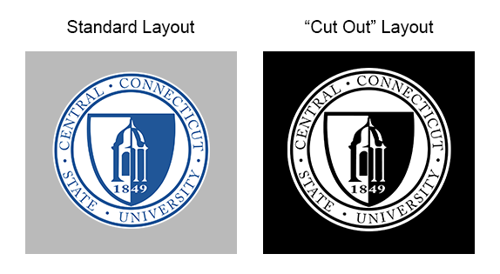

## **Incorrect Usage**

The following logos violate the design of the CCSU Crest.

The first shows the logo with the white out ring removed. This version can appear awkward in different contexts since the blue on the edge of the logo may interact poorly with whatever background elements it is placed next to.

The second shows the white of the logo being removed, and the blue of the logo turned white. This version improperly displays the logo, and creates a less 'solid' design while distorting the perception of the Clock Tower.

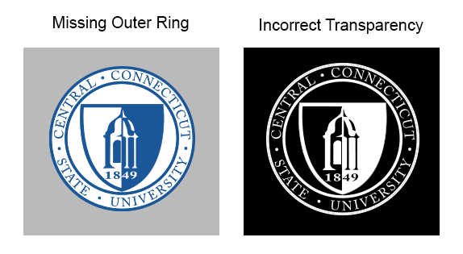

## **Logotype Layout**

There are two acceptable formats for the logo to display the name of the university. The line separating 'CENTRAL' from the rest of the university's name is optional but writing out the entire name is not.  
The official font for the text is Adobe Garamond Pro.

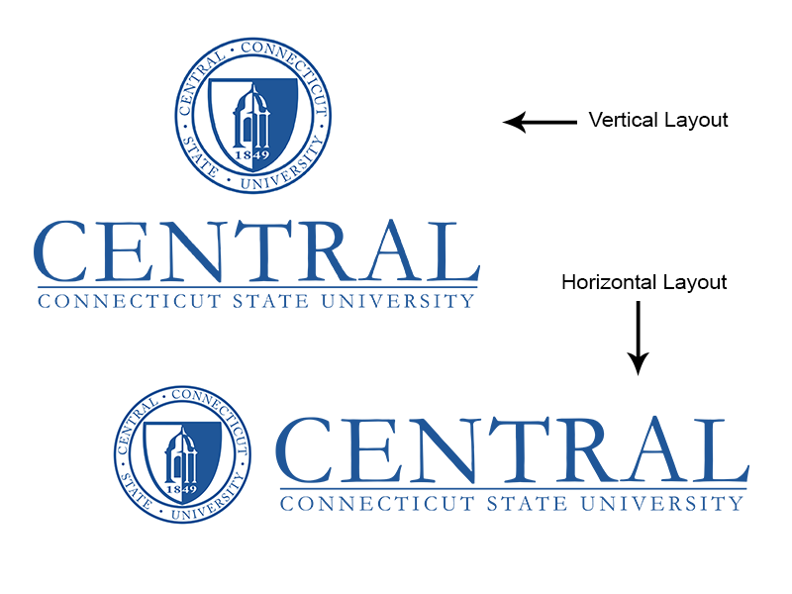

#### 

### Mobile Responsive Design

Mobile browsing on phones and tablets is skyrocketing. As a result, the CCSU site has been designed to accommodate any device screen size. This flexibility, while crucial and convenient, does create additional considerations when developing and designing a website.

### Web Accessibility

Every CCSU website must be [508](http://www.hhs.gov/web/section-508/) and [W3C](https://www.w3.org/standards/) compliant.